**UIPATH HR&FINANCE USE CASES**

**1. Resume screening and candidate shortlisting**

**Overview:**

Nowadays you no longer need to ask your employees to spend a lot of time going through many resumes and application forms received for open positions. Software robots can easily gather all the files and compare the information with the list of job requirements.

**Challenge:**

Organizations that recruit in bulk have to deal with thousands of resumes every week

It is a near-impossible task for recruitment teams to screen hundreds of resumes manually and make accurate decisions all the time.

The high volume of resumes and repetitive screening process becomes a challenge for human resources teams

With manual intervention, there is some amount of bias that can lead to a flawed hiring process

**Solution:**

This automation can be developed to screen through the thousands of resumes / LinkedIn profiles to find the right candidates for the job

Bot is used to search and filter out the aspect candidate from job portal.

1. Get the job description detail from database.

2. Check the status of the JD and select which one should be new / rerun.

3. Get the required number of candidate count from the JD.

4. Select the JOB portal (Indeed, monster, LinkedIn, Dice) from the JD.

5. Enter the searching field from JD and search the candidate.

6. If candidate is right fit then extract the candidate info and update in excel by setting priority number.

7. If candidate is not right fit, then check for next candidate.

8. Once the candidate is shortlisted, the bot send automated emails to find if the candidate is open to opportunities

9. Bot set up the automated interview process for the candidate based on the calendar availability of the technical panel and upload the extracted candidate info into the database.

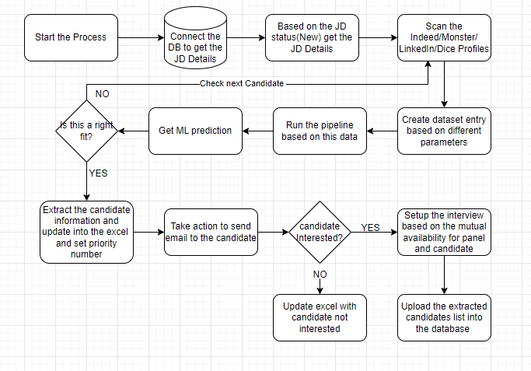

**Benefits:**

Enable recruiters to focus on strategic activities

Higher accuracy

Quicker processing of resumes

Higher efficiency and scale

**2. Employee offboarding/Exit processes**

**Overview:**

Every industry has been seeking opportunities to optimize business processes to be more competitive with fewer resources for manual, tedious, and repetitive activities. The HR Offboarding process of employees and contractors is a great example how Robotic Process Automation and RPA can help.

**Challenge:**

The manual offboarding processes can be sometime hectic and time consuming and can cause errors.

Deactivating the user email account

Disabling the user account in the AD

Removing AD groups

Removing CRM license and groups

Reassigning IT tasks for exception handling

Notifying HR and IT when the process was completed

**Solution:**

The UiPath robot extracted data from various systems, internal and external Desktop applications, and Web applications to validate and process the data. The bot can automatically disable the account for the employee in various end systems.

1. Bot will check if the employee resignation is accepted and after the resignation acceptance it will check the notice period date.

2. After that it will also check for the approval by the departments that is required at the time of offboarding.

3. If the approval is given by the respective departments it will check for the accounts present in the respective end-systems.

4. If accounts are present the bot will automatically Delete All the Accounts Linked with the Employee Details. If not the bot will Inform the HR Department and also Mail the details to the IT Team.

5. At the end of this the Bot will automatically generate one mail and will inform to the team about the offboarding of the Employee.

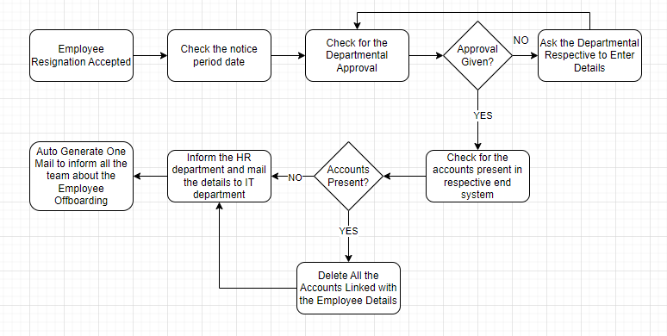

**Benefits**

Reduced user manual input process steps

Reduced IT workload

100% data entry accuracy

100% Internal and external audit compliance.

Reduced user software licensing costs.

**3. Accounts Payable and Receivable (Invoice Creation)**

**Overview:**

Accounts Payable (AP) and Accounts Receivable (AR) are the financial lifeblood of any organization. But beneath the vital nature of these operations, they often represent a quagmire of repetitive, rule-based tasks that can significantly consume an accountant’s resources and time.

**Challenge:**

Timing: It takes few days for companies to process an invoice from receipt through payment approval.

Cost: If done manually, both the cycle time and the cost are affected.

Data extraction: Optical character recognition (OCR) data extraction involves conversion of images of typed or printed text into machine-encoded text, whether from a scanned document or photo of a document—which is an even more complex process than RPA bots are usually equipped to handle.

**Solution:**

RPA and AI can automate a range of manual tasks, eliminating most payment delays and human errors.

1. Intelligent data capture from different types of invoices (physical, scanned, emailed, faxed, electronic data interchange – EDI)

2. Invoice classification and sorting

3. Duplicate invoice checking

4. Data validation against ERP

5. Invoice exception flagging

6. Invoice approval routing

7. Automated tasks and reminders for payment

8. Seamless flow of information through discrete systems

9. Reporting and analytics

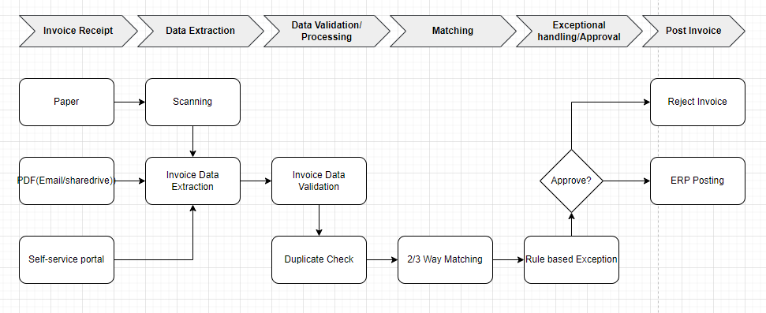

**Benefits:**

1. Efficiency Boost: The time taken from receiving an invoice to its final payment or receipt is significantly reduced, enhancing operational efficiency.

2. Error Reduction: By automating data-intensive tasks, the room for manual errors, be it from data entry or oversight, is minimized.

3. Accelerated Payment Cycle: A streamlined AP and AR process leads to quicker payments and receipts, positively impacting the organization’s cash flow.

4. Faster Payment Approvals, Priorities Payments, Proactive Overdue Payment Reminders, Timely Reminders

**4. Bank Reconciliation Process**

**Overview:**

Bank Reconciliation is a process followed by almost every company to maintain its financial health. The company’s transactions are reconciled on a monthly, weekly or daily basis.

Reconciliation involves a manual effort to precisely compare the large volumes of data from the company’s bank account statement to the financial records maintained by the company. In the end of which the balance in the company’s bank statement and the amount in the financial records should tally.

**Challenge:**

Large volumes of data

Data formats in Bank Statements or Company’s financial records

Highly time Consuming

**Solution:**

1. Bot Extracts and Formats Data from Bank statements & Company’s Records

2. Reconciles the Data

3. Submits Reconciled Data back to Company’s systems

4. Creates and exception report for day’s run

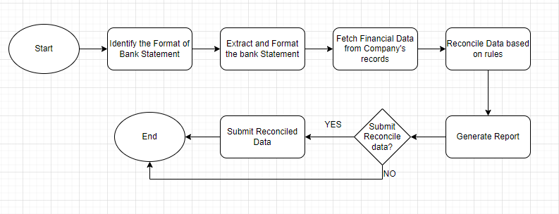

**Benefits:**

Improved the accuracy and speed of reconciliations

Provides visibility of data to trace the data from its sources like Banks Statements, matching, exception management and final submission. Useful in case of audits for traceability and transparency

Reduces the risk of human-generated data errors as much as 50%.

Analyzing and evaluating high volumes of data quickly, accurately and efficiently. Providing reliability.

It also provides the reconciled report to the Accounting staff at the end of the day for any of the exceptions that the RPA could not handle. Humans can use their cognitive skills to solve the exceptions.

Eases the tedium of looking at accounting sheets all day by the Accounting staff.

Re-run matching process as and when the new Bank Statements are received.